Pseudocode for SmartCleanerBot:
PROCEDURE SmartCleanerBot
SET height ← 5
SET width ← 5
SET room ← GET_INPUT_GRID()
SET location ← [0, 0]
INITIALIZE checked_cells ← {(0, 0)}
INITIALIZE path ← [(0, 0)]
INITIALIZE logbook ← []
SET directions ← [(-1,0), (1,0), (0,-1), (0,1)] // up, down, left, right

PROCEDURE GET_INPUT_GRID
PRINT "Input 5 rows of 0 (clean) or 1 (dirty)"
INITIALIZE matrix ← []
FOR i FROM 0 TO 4
LOOP UNTIL valid row is entered
READ row_input AS list of integers
IF length of row_input ≠ 5 OR values not in {0,1}
PRINT error message
CONTINUE
APPEND row_input TO matrix
RETURN matrix

PROCEDURE IS_DIRTY_SPOT
RETURN room[location[0]][location[1]] == 1

PROCEDURE SWEEP
IF IS_DIRTY_SPOT is TRUE
SET room[location[0]][location[1]] ← 0
APPEND "Swept dirt at (x, y)" TO logbook
PRINT log and updated room
RETURN TRUE
ELSE
RETURN FALSE

PROCEDURE IS_INSIDE(x, y)
RETURN x ∈ [0, height-1] AND y ∈ [0, width-1]

PROCEDURE IS_CLEANED
FOR EACH cell IN room
IF cell == 1
RETURN FALSE
RETURN TRUE

PROCEDURE EXPLORE_AND_CLEAN
WHILE path IS NOT EMPTY
SET (x, y) ← location

IF IS_DIRTY_SPOT()
CALL SWEEP()

INITIALIZE next_moves ← []
FOR EACH (dx, dy) IN directions
SET nx ← x + dx, ny ← y + dy
IF IS_INSIDE(nx, ny) AND (nx, ny) NOT IN checked_cells
APPEND (nx, ny) TO next_moves

IF next_moves IS NOT EMPTY
SET next_cell ← next_moves[0]
APPEND next_cell TO path
ADD next_cell TO checked_cells
SET location ← next_cell
APPEND "Moved to (x, y)" TO logbook
PRINT log and updated room
ELSE
POP last position FROM path
IF path IS NOT EMPTY
SET location ← last item in path
APPEND "Backtracked to (x, y)" TO logbook
PRINT log and updated room

IF IS_CLEANED() is TRUE
BREAK

PROCEDURE START
PRINT "Initial Room State"
PRINT room
CALL EXPLORE_AND_CLEAN()
PRINT "Final Room State"
PRINT room

CALL START()

Flowchart

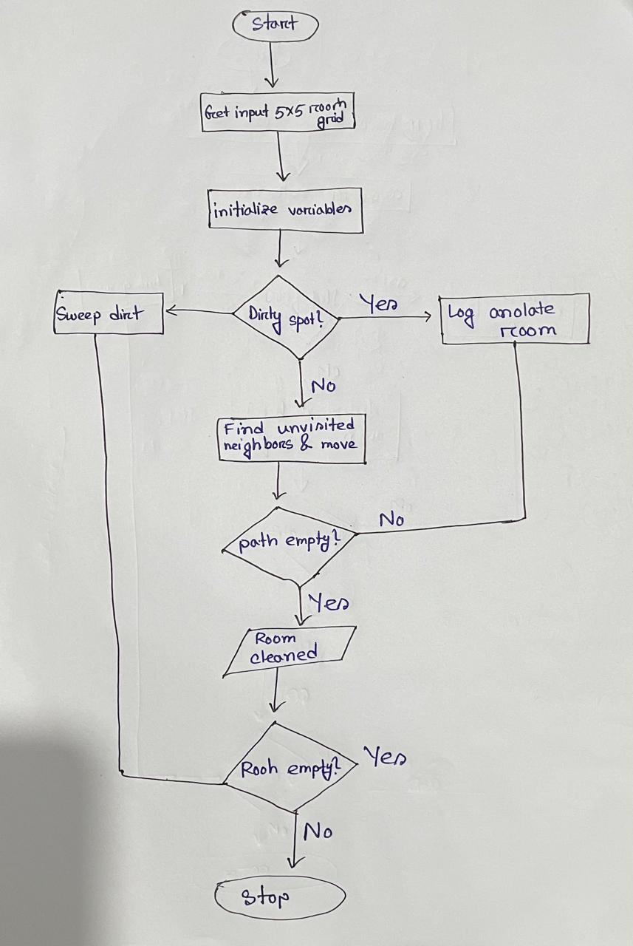

Reflection: How My Agent Decides Actions
My agent follows a depth-first search (DFS) strategy to clean a 5x5 grid environment. It begins at the top-left cell and first checks if the current cell is dirty. If it is, the agent cleans it. Then, it looks for unvisited neighboring cells and moves to the first one it finds, marking it as visited. If no unvisited neighbors are available, the agent backtracks to the previous cell using a stack. This process continues until all dirty cells are cleaned. By tracking visited cells and avoiding repetition, the agent ensures efficient and complete cleaning with minimal unnecessary movement.

